ACCOUNTS BACKEND PROJ.

DOCUMENTATION – END USER MANUAL GUI

JAN 27th, 2019. Author: Guillermo Vazquez Gonzalez

# Index

Index, 2

Create Account, 4

Delete Account, 6

List Accounts, 3

Update Account, 5

# List Accounts

1. - Open your browser and hit URL [http://localhost:8080/list].
2. Available accounts will be displayed.

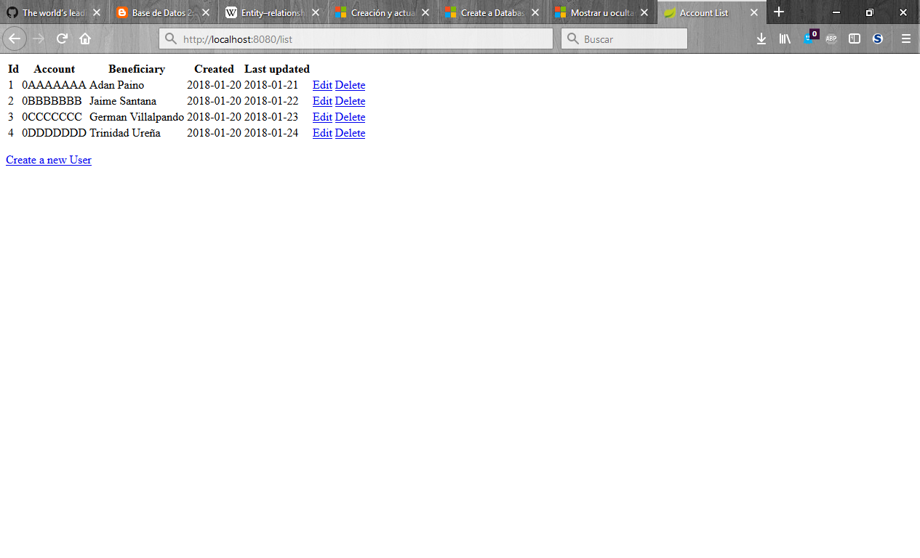

# Create Account

1. Open your browser and hit URL [http://localhost:8080/list].
2. Jump in “Create new Account” Link
3. Provide Account information and click “Submit Account” Button.
4. You will be directly redirected to the “List Accounts” Page.

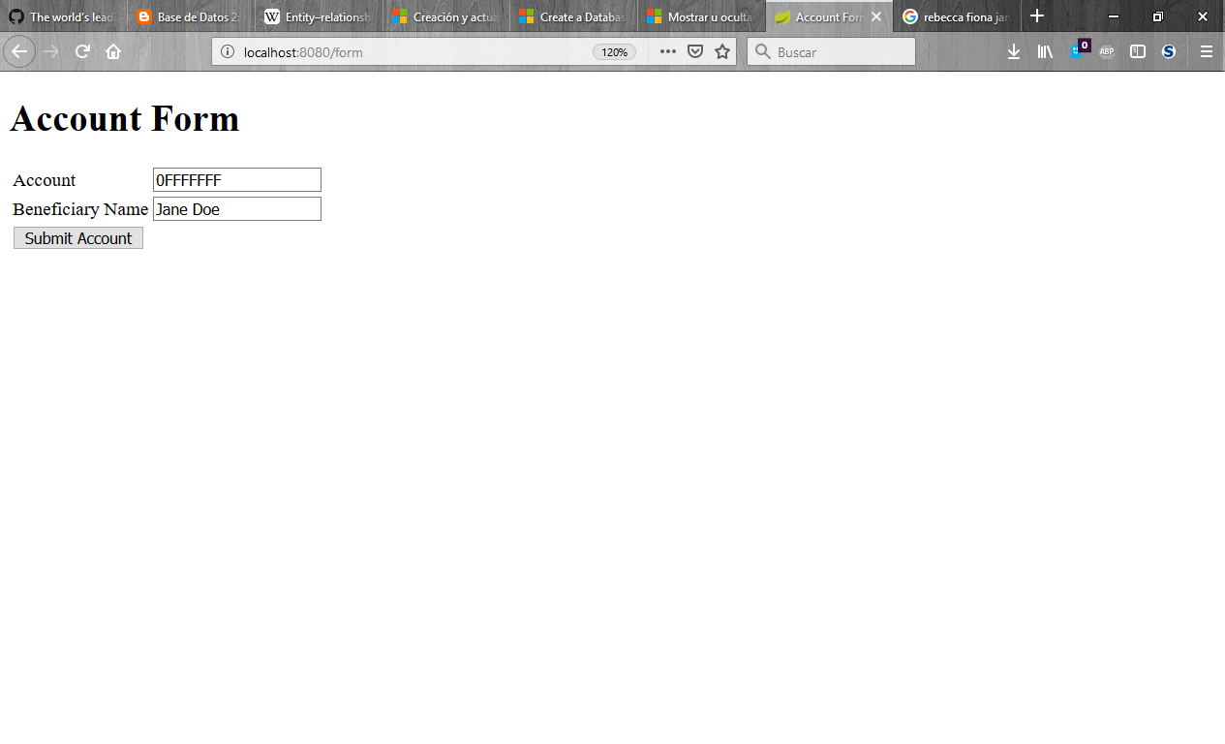

# Update Account

1. Open your browser and hit URL [http://localhost:8080/list].
2. Identify the account that you would like to update and click the “Edit” Link located on the same row.
3. Provide the new Account information and click “Submit Account” Button.
4. You will be directly redirected to the “List Accounts” Page.



# Delete Account

1. Open your browser and hit URL [http://localhost:8080/list].
2. Identify the account that you would like to delete and click the “Delete” Link located on the same row.
3. You will be directly redirected to the “List Accounts” Page.

